Instructions for Abstract Submission

1. The submitted abstract may be either first publish or published elsewhere. The copyright belong to authors. The abstract is only for the academic communication.

2. All abstracts must submitted to LSACJ 2017 must include the title, author names, affiliations, abstract text(Background and objective, methods, results, conclusion) and/or graph, figures or table, references, acknowledgment, author information. Please fill in the text and figures following the template below.

3. You can chose any one language of English, Chinese or Japanese to finish this template. If you use the non-english version, English title, authors name, institute, address, e-mail and abstract text is necessary.

4. Abstract text is better to be more than one page. We recommend you to use the formation in the template.

5. In the template, the option items are perspective, acknowledgement, figures, and tables.

6. For effective communication, author information is necessary, including author Name，applications，research filed，major publications，CV，free words. Please provide us high solution personal photo.

7. If you want to give an oral presentation, please check the box at the start in the template. The presenters will be selected by the committees.

8. In addition, the contributor will become the member of LSACJ automatically. If you refuse, please tell us.

9. Submission methods: Please submit the abstract to the E-mail, <conference@lsacj.org> with word format.

1. **Template:**

**Oral presentation yes no a**

English Title for this Manuscript to LSACJ2016

Hanako SEIMEI1, 2, 3, #, Taro SEIMEI1, #, Yixue WANG2, Jane F. BLACK1, 2, [1]*

**Graphic abstract**： (If you have a graphical abstract, it should be attached before abstract)

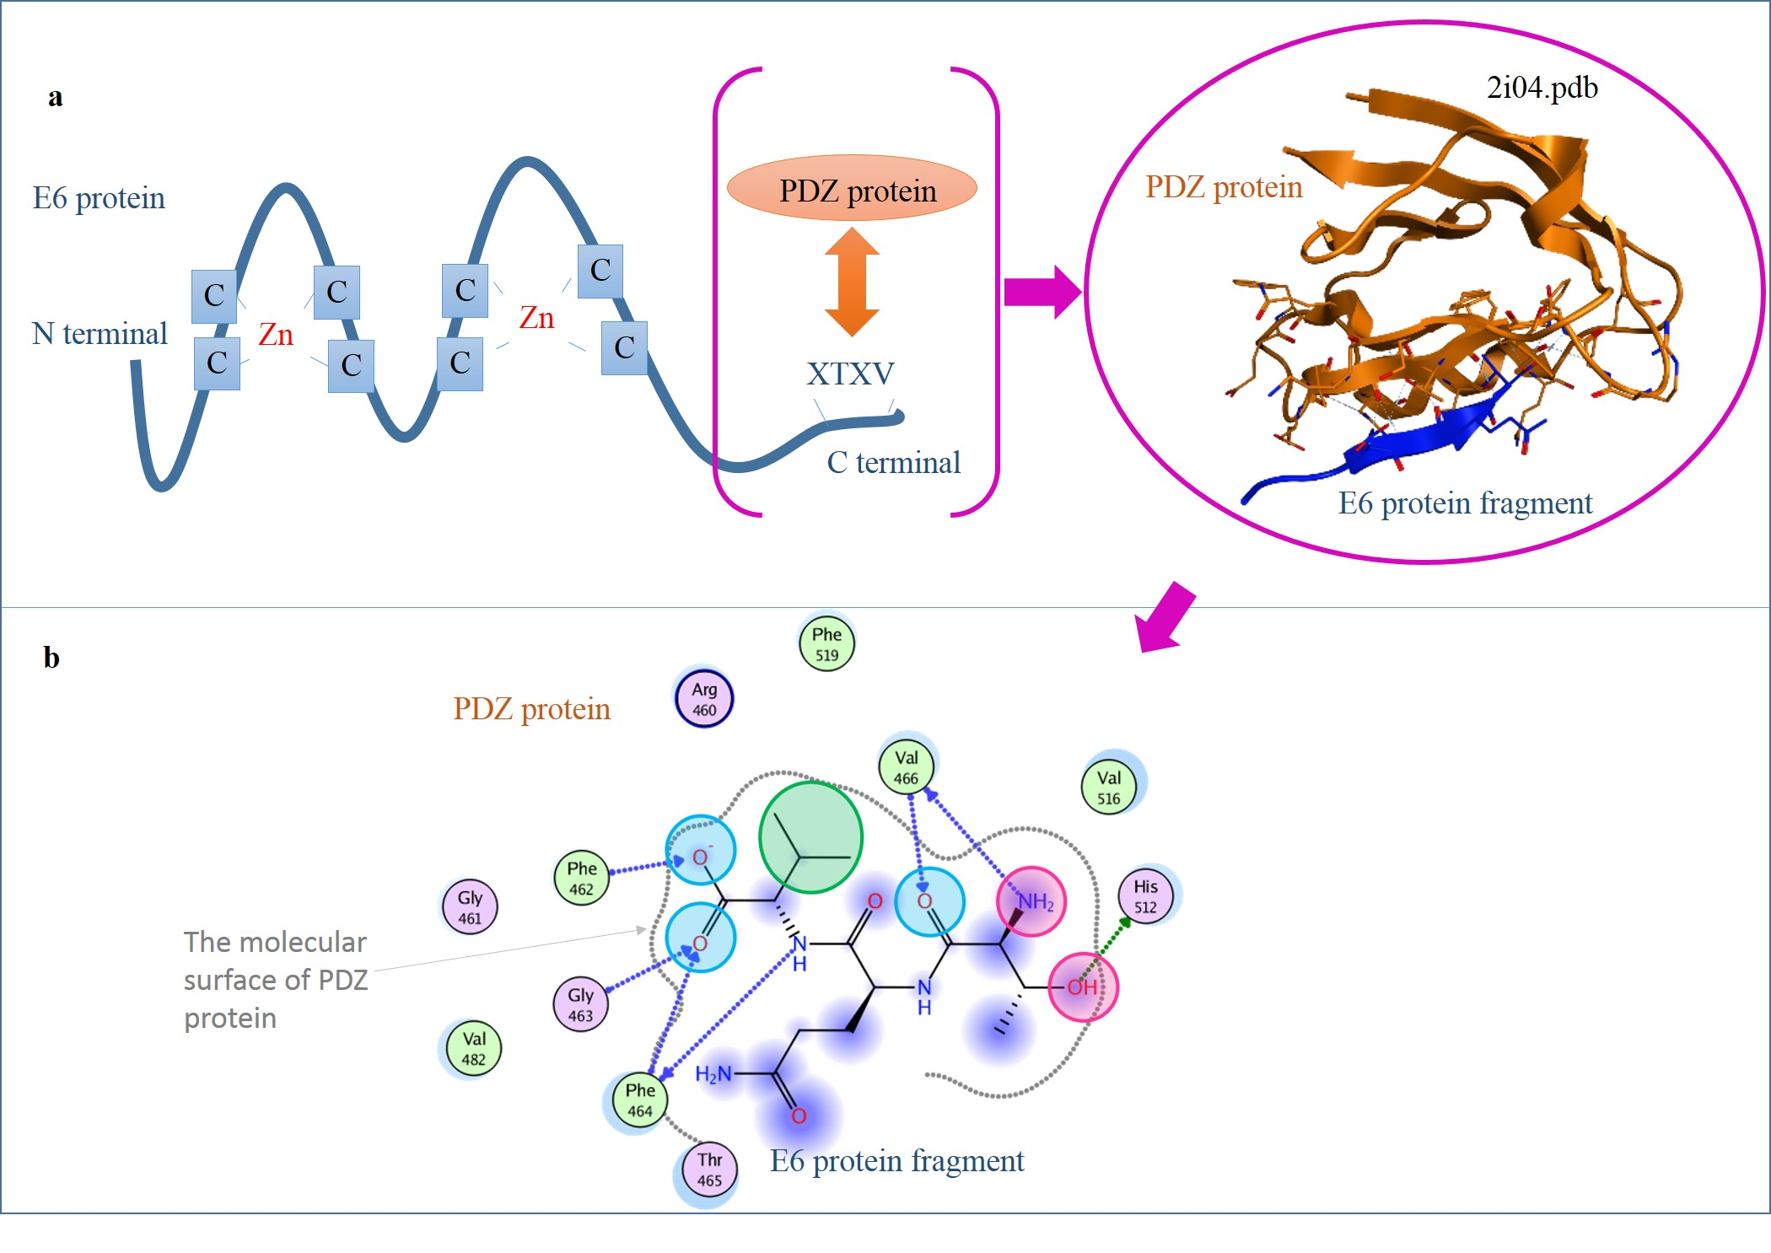

**Abstract**: (This part is more than 300 words.)

**Background and objective**: Describe the main objective(s) of the study.

**Methods**: Explain how the study was done, including any model organisms used, without methodological detail.

**Results**: Summarize the most important results.

**Conclusions**: Clearly state the implications of the answers your results gave you，and point out their significance.

Key words: life, DNA, evolution, a maximum of five keywords

Abbreviations: Standard abbreviations and units should be used. Abbreviations should be defined at first mention and used consistently thereafter.

**Figure 1, 2, 3, ... , and legends**

(If you have some figures or tables related with this presence, it should be attached as below.)



Fig.１　Title

Explanations

**Table 1, 2, 3, ... ,**

Table１　Title

|  |  |  |  |
| --- | --- | --- | --- |
|  | IC50 | EC50 | SI |
| A |  |  |  |
| B |  |  |  |
| C |  |  |  |

Explanations

**Acknowledgment**

This research was supported by xxx foundation.

**References**

[1] lsacj.org | last access 2016/06/20

[2] Ma, X., Tan, J., Su, M., Li, C., Zhang, X., and Wang, C. (2014). Molecular dynamics studies of the inhibitor C34 binding to the wild-type and mutant HIV-1 gp41: inhibitory and drug resistant mechanism. PLoS ONE 9, e111923.

[3] Su, Y., Chong, H., Qiu, Z., Xiong, S., and He, Y. (2015). Mechanism of HIV-1 Resistance to Short-Peptide Fusion Inhibitors Targeting the Gp41 Pocket. J Virol 89, 5801–5811.

[4] Zhang, D., Li, W., and Jiang, S. (2015). Peptide fusion inhibitors targeting the HIV-1 gp41: a patent review (2009 - 2014). Expert Opin Ther Pat 25, 159–173.

**-----------------------------------**

**Author information**

AUTHOR (ATTENDEE) INFORMATION.



Author Name: Taro SEIMEI, PhD., MD.

Applications: LSACJ

Research Filed:

Immunology, Bioinformatics

Major Publications:

1) SEIMEI, T. et.al., PLoS ONE x, exxxx.

2) SEIMEI, T. et.al., Science x, xxx-xxx.

3) SEIMEI, T. et.al., Science x, xxx-xxx.

4) SEIMEI, T. et.al., Science x, xxx-xxx.

CV:

Got PHD. @ Beijing Uni. in 2003

Became a medical doctor in 2005

Associated Prof. @ university of Liverpool (2006-2012)

Prof. @ Qingdao Uni. China

Free words:

We do not know anything better than God, but biology does.

1. * Correspondence to J.F. BLACK Email: JF_black@yahoo.com

   1 B department, A center, Life Science Association of Chinese in Japan, 565-xxxx, 1-787, Choo ku, Osaka City, Osaka, Japan

   2 B department, A center, B University, xxx-xxxx, , 1112, Caoyang Men, Beijing, China

   3 B department, A center, C University, 565-xxxx, 2121xx Road, London, England

   # H. SEIMEI and T. SEIMEI worked equally in current work. (FONT: Century 6.5)